CIA-2

ROLL NO:727721euit032

NAME:DHIVAGAR R

1.CODE:

public class CA2 {

@Test

public void f()throws InterruptedException {

WebDriverManager.chromedriver().setup();

WebDriver driver;

ChromeOptions co = new ChromeOptions();

co.addArguments("--remote-allow-origins=*");

driver=new ChromeDriver(co);

driver.manage().window().maximize();

driver.get("https://www.trivago.in/");

Thread.sleep(2000);

String actualTitle="trivago.in - Compare hotel prices worldwide";

String extractedTitle=driver.getTitle();

AssertJUnit.assertEquals(actualTitle, extractedTitle);

System.out.println("Page title is Validated.");

Thread.sleep(2000);

WebElement location=driver.findElement(By.xpath("//*[@id=\"__next\"]/div[1]/div[1]/section/div[2]/div[3]/div/div[1]/div/form/div"));

location.click();

Thread.sleep(2000);

WebElement ben=driver.findElement(By.xpath("//*[@id=\"suggestion-list\"]/ul/li[1]/div/div"));

ben.click();

Thread.sleep(2000);

WebElement cin=driver.findElement(By.xpath("//*[@id=\"__next\"]/div[1]/div[1]/section/div[2]/div[3]/div/div[2]/div/div/div/div[2]/div/div[1]/div[2]/button[2]/time"));

cin.click();

Thread.sleep(2000);

// WebElement coutcol=driver.findElement(By.xpath("//*[@id=\"__next\"]/div[1]/div[1]/section/div[2]/div[3]/div/div[1]/fieldset/button[2]/span"));

// coutcol.click();

WebElement cout=driver.findElement(By.xpath("//*[@id=\"__next\"]/div[1]/div[1]/section/div[2]/div[3]/div/div[2]/div/div/div/div[2]/div/div[1]/div[2]/button[7]/time"));

cout.click();

Thread.sleep(2000);

WebElement inc=driver.findElement(By.xpath("//*[@id=\"__next\"]/div[1]/div[1]/section/div[2]/div[3]/div/div[2]/div/div/div[1]/div/div[1]/div[1]/div/button[2]/span/span[1]"));

inc.click();

inc.click();

inc.click();

Thread.sleep(2000);

WebElement pet=driver.findElement(By.id("checkbox-13"));

pet.click();

Thread.sleep(3000);

WebElement apply=driver.findElement(By.xpath("//*[@id=\"__next\"]/div[1]/div[1]/section/div[2]/div[3]/div/div[2]/div/div/div[2]/div/button[2]"));

apply.click();

Thread.sleep(3000);

if(driver.getTitle().equals("Bengaluru (Pet friendly) Hotels | Find & compare great deals on trivago")) {

System.out.println("1.Verified that the user can enter the location of stay.");

System.out.println("2.Verified that the user can select the check-in and check-out date.");

System.out.println("3.Verified that the user can enter the no of rooms based on their preference.");

}

}

}

OUTPUT:

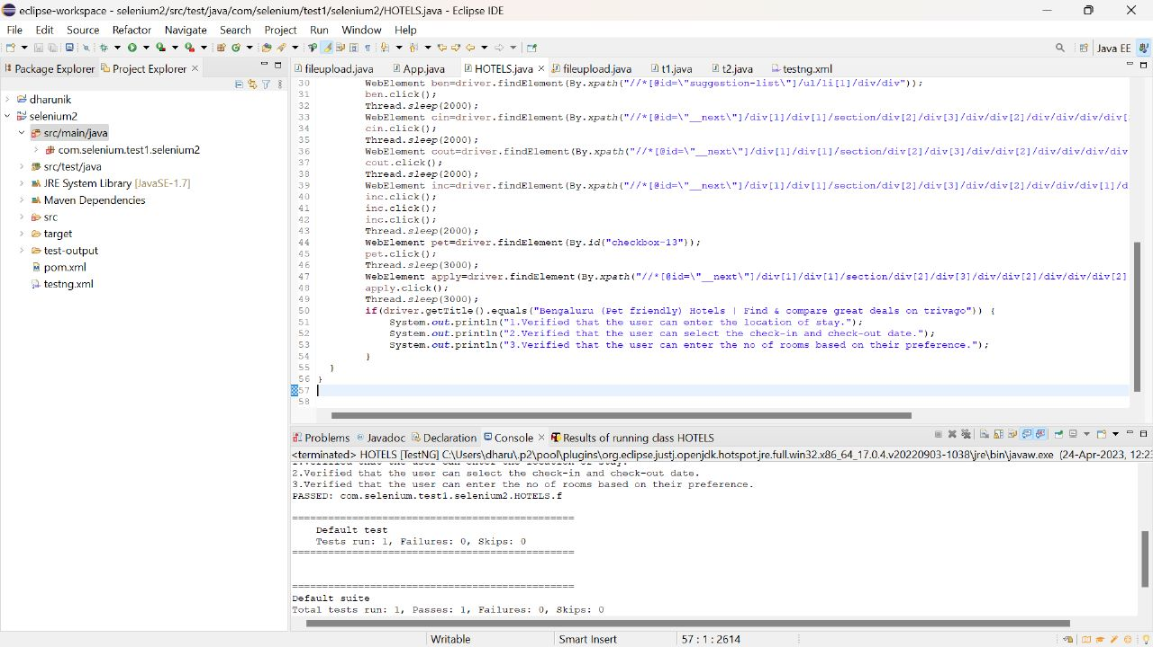

2.CODE:

***package com.selenium.cia2;***

***import org.testng.annotations.Test;***

***import io.github.bonigarcia.wdm.WebDriverManager;***

***import static org.junit.Assert.assertTrue;***

***import org.junit.AfterClass;***

***import org.junit.BeforeClass;***

***import org.openqa.selenium.By;***

***import org.openqa.selenium.WebDriver;***

***import org.openqa.selenium.WebElement;***

***import org.openqa.selenium.chrome.ChromeDriver;***

***import org.openqa.selenium.chrome.ChromeOptions;***

***public class TC_002 {***

***WebDriver driver;***

***@BeforeClass***

***public void setup() {***

***WebDriverManager.chromedriver().setup();***

***ChromeOptions co=new ChromeOptions();***

***co.addArguments("--remote-allow-origins=*");***

***driver=new ChromeDriver(co);***

***driver.get("https://www.trivago.in/");***

***driver.manage().window().maximize();***

***}***

***@AfterClass***

***public void teardown() {***

***driver.quit();***

***}***

***@Test***

***public void testSortingByPriceAndRecommendations() {***

***WebElement sortDropdown = driver.findElement(By.cssSelector(".df_overlay_container [data-qa='sort-dropdown']"));***

***sortDropdown.click();***

***WebElement priceAndRecOption = driver.findElement(By.cssSelector("[data-qa='sort-option'][data-option-id='2']"));***

***priceAndRecOption.click();***

***WebElement hotelList = driver.findElement(By.cssSelector("[data-qa='itemlist-section']"));***

***WebElement firstHotel = hotelList.findElement(By.cssSelector("[data-qa='item'][data-index='0']"));***

***WebElement hotelName = firstHotel.findElement(By.cssSelector("[data-qa='item-name']"));***

***WebElement hotelPrice = firstHotel.findElement(By.cssSelector("[data-qa='recommended-price']"));***

***System.out.println(hotelName.getText() + " - " + hotelPrice.getText());***

***assertTrue(hotelPrice.isDisplayed());***

***}***

***@Test***

***public void testSortingByPrice() {***

***WebElement sortDropdown = driver.findElement(By.cssSelector(".df_overlay_container [data-qa='sort-dropdown']"));***

***sortDropdown.click();***

***WebElement priceOption = driver.findElement(By.cssSelector("[data-qa='sort-option'][data-option-id='1']"));***

***priceOption.click();***

***WebElement hotelList = driver.findElement(By.cssSelector("[data-qa='itemlist-section']"));***

***WebElement firstHotel = hotelList.findElement(By.cssSelector("[data-qa='item'][data-index='0']"));***

***WebElement hotelName = firstHotel.findElement(By.cssSelector("[data-qa='item-name']"));***

***WebElement hotelPrice = firstHotel.findElement(By.cssSelector("[data-qa='recommended-price']"));***

***System.out.println(hotelName.getText() + " - " + hotelPrice.getText());***

***assertTrue(hotelPrice.isDisplayed());***

***}***

***@Test***

***public void testNumberOfStaysFound() {***

***WebElement hotelList = driver.findElement(By.cssSelector("[data-qa='itemlist-section']"));***

***int numberOfStays = hotelList.findElements(By.cssSelector("[data-qa='item']")).size();***

***System.out.println("Number of stays found: " + numberOfStays);***

***assertTrue(numberOfStays > 0);***

***}***

***@Test***

***public void testNumberOfBookingSitesSearched() {***

***WebElement bookingSitesDropdown = driver.findElement(By.cssSelector(".df_overlay_container [data-qa='booking-sites-dropdown']"));***

***bookingSitesDropdown.click();***

***int numberOfSites = driver.findElements(By.cssSelector(".df_overlay_container [data-qa='booking-site-item']")).size();***

***System.out.println("Number of booking sites searched: " + numberOfSites);***

***assertTrue(numberOfSites > 0);***

***}***

***}***

***Output:***

